Technical Specification Form

SAP Routing Details

**Technical specification content**

1. Business Requirement
2. Development Tools
3. Development Objects

* Table used.
* DDIC Structure.
* SEGW – OData Project.

1. Business API / OData API and Output Screen

**1.Business Requirement**

Develop an OData API for Production Version data , through which Business user can check Production Version data in External SAP application .In the External SAP application, user can able to see following details in a List view manner based on Created On Or Changed On Filter Criteria.



**2.Development Tools**

* **ABAP Dictionary (SE11)**
* DDIC Data Type : Used to Crete DDIC structure for import operation for Data modeling at OData Project.
* **SEGW OData Project**
* Created OData project where for data modeling Used import to DDIC Structure..
* For Service Registration used Tcode : /O/IWFND/MAINT_SERVICE.
* To Check the final data at Gateway Client used Tcode /O/IWFND/GW_CLIENT

**3. Development Objects :**

* Table used :
* **MKAL**: Production Version Of Material.
* DDIC Structure :
* **ZPP_PRODUCTION_VERSION_ST** : Structure for SAP production Version Data
* SEGW OData Project :

Project Name: ZGW_PP_PRODUCTION_VERSION

Service Name: ZGW_PP_ PRODUCTION_VERSION_SRV

Entity Type: ProductionVerion  
Entity set: ProductionVersionSet

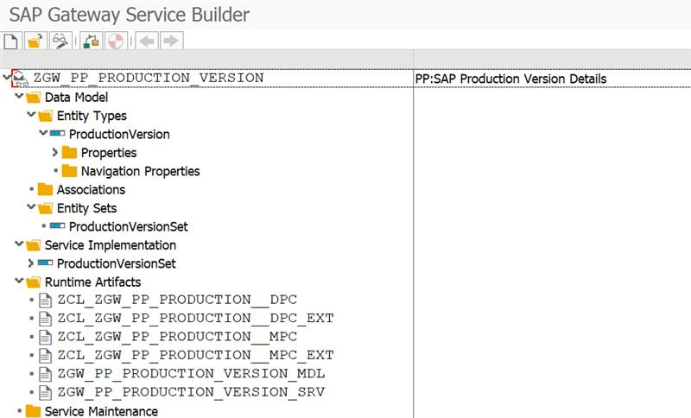**Screenshot :**

**Logic Written for GET Production version data :**

**C**LASS : ZCL_ZGW_PP_PRODUCTION__DPC_EXT

Method :  PRODUCTIONVERSIO_GET_ENTITYSET.

* method PRODUCTIONVERSIO_GET_ENTITYSET.  
      TYPES: BEGIN OF ty_plant_range,  
           sign   TYPE c LENGTH 1,  
           option TYPE c LENGTH 2,  
           low    type WERKS_d,  
           high   type werks_d,  
         END OF ty_plant_range.  
    
      data: ls_filter TYPE /iwbep/s_mgw_select_option,  
            ls_PRDAT_DATE_RANGE TYPE  TRGS_DATUM,  
            lt_prdat_date_range TYPE TRGR_DATE,  
            r_plant type TABLE OF TY_PLANT_RANGE,  
            ls_plant type TY_PLANT_RANGE.  
    
        *"-->Check Authorized Plant Based on User.*  
        select werks from t001w INTO TABLE @data(tab_Plant).  
          IF sy-subrc eq 0.  
            LOOP AT TAB_PLANT INTO data(wa_plant).  
              AUTHORITY-CHECK OBJECT 'ZPLANTS'  
              ID 'WERKS' FIELD wa_plant-WERKS.  
               IF SY-SUBRC eq 0.  
                 CLEAR:ls_plant.  
                 Ls_PLANT-sign   = 'I'.  
                 Ls_PLANT-option = 'EQ'.  
                 Ls_PLANT-low    = wa_plant-WERKS.  
                 APPEND Ls_PLANT to R_PLANT.  
               ENDIF.  
               CLEAR:wa_plant.  
            ENDLOOP.  
          ENDIF.  
    
         *"--> Fetch Data based on Finter Condition or Without Filter Condition.*  
        IF IT_FILTER_SELECT_OPTIONS is not INITIAL.  
         READ TABLE IT_FILTER_SELECT_OPTIONS INTO LS_FILTER  WITH KEY PROPERTY = 'Prdat'.  
          IF sy-subrc eq 0.  
            LOOP AT LS_FILTER-SELECT_OPTIONS ASSIGNING FIELD-SYMBOL(<fs_data>).  
              LS_PRDAT_DATE_RANGE-LOW = <FS_DATA>-LOW.  
              LS_PRDAT_DATE_RANGE-HIGH = <FS_DATA>-HIGH.  
              LS_PRDAT_DATE_RANGE-SIGN = 'I'.  
              LS_PRDAT_DATE_RANGE-OPTION = 'BT'.  
              APPEND LS_PRDAT_DATE_RANGE TO LT_PRDAT_DATE_RANGE.  
            ENDLOOP.  
            SELECT * FROM mkal INTO CORRESPONDING FIELDS OF TABLE ET_ENTITYSET  
            WHERE PRDAT in LT_PRDAT_DATE_RANGE and  
                  WERKS in R_PLANT.  
          ENDIF.  
         else.  
           SELECT * FROM mkal INTO CORRESPONDING FIELDS OF TABLE ET_ENTITYSET  
           WHERE WERKS in R_PLANT.  
        ENDIF.  
    endmethod.

**4.Business API / OData API and Output Screen Screenshot:**

Here filtration is done based on MKAL table’s Prdat(Date of last check of Production Version) and in the Enity set that field name is also named as **‘Prdat’**.

**Tested API with Output Screenshot:**

*Here I used one User Who had only 3001 Plant authorization. maybe for Different user this output differ for this tested Date range.*

**API**

/sap/opu/odata/sap/ZGW_PP_PRODUCTION_VERSION_SRV/ProductionVersionSet?$filter=Prdat ge datetime'2025-05-24T00:00:00' and Prdat le datetime'2025-08-18T00:00:00'

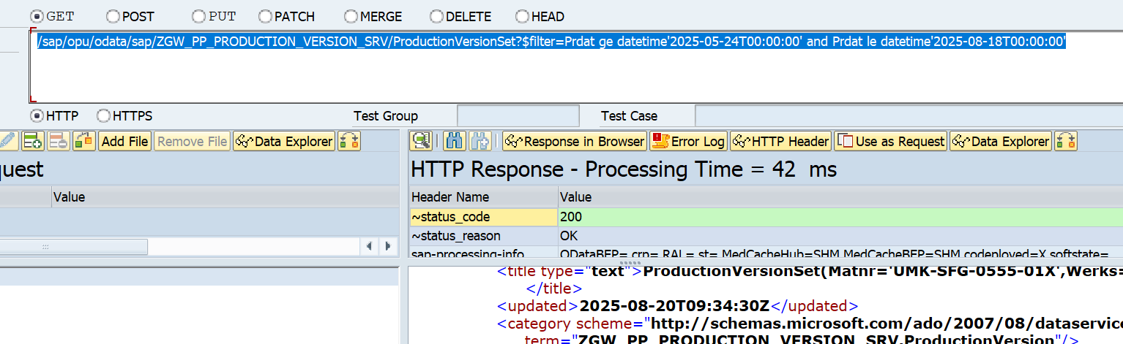

**Count Record URL for this date range :**

/sap/opu/odata/sap/ZGW_PP_PRODUCTION_VERSION_SRV/ProductionVersionSet/$count?$filter=Prdat ge datetime'2025-05-24T00:00:00' and Prdat le datetime'2025-08-18T00:00:00'

OUTPUT: #COUNT = 7

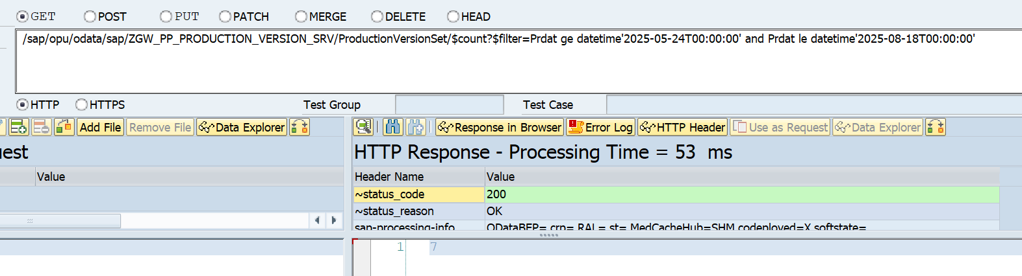

**Database table Number of record for this date range:**  
